INFLUENTIAL FACTORS AFFECTING SALES AT WALMART AND PREDICTING SALES AT WALMART USING LINEAR REGRESSION.

*ANUPAMA KADAMBI ASU ID:1222559637*

**> Goal:** To find the most influential factors that contribute to sales at Walmart supercenters.

To fit a linear regression model to the dataset and predict the sales at Walmart.

**>Dataset:** Source- Kaggle. Online community for statisticians and data scientists, who publish datasets and are validated by other on the platform.

Total number of predictors: 8. No. of numerical predictors: 4 No. of categorical predictors: 4

Response variable- Weekly sales Temperature, Fuel price, Store number, Holiday Flag

Unemployment rate, CPI. Date (Months, Years)

**>Methodology:**

EXPLORATORY DATA ANALYSIS

HISTOGRAMS BOXPLOT SALES VS NUM. PREDICTORS.

1. Sales

1. Temperature

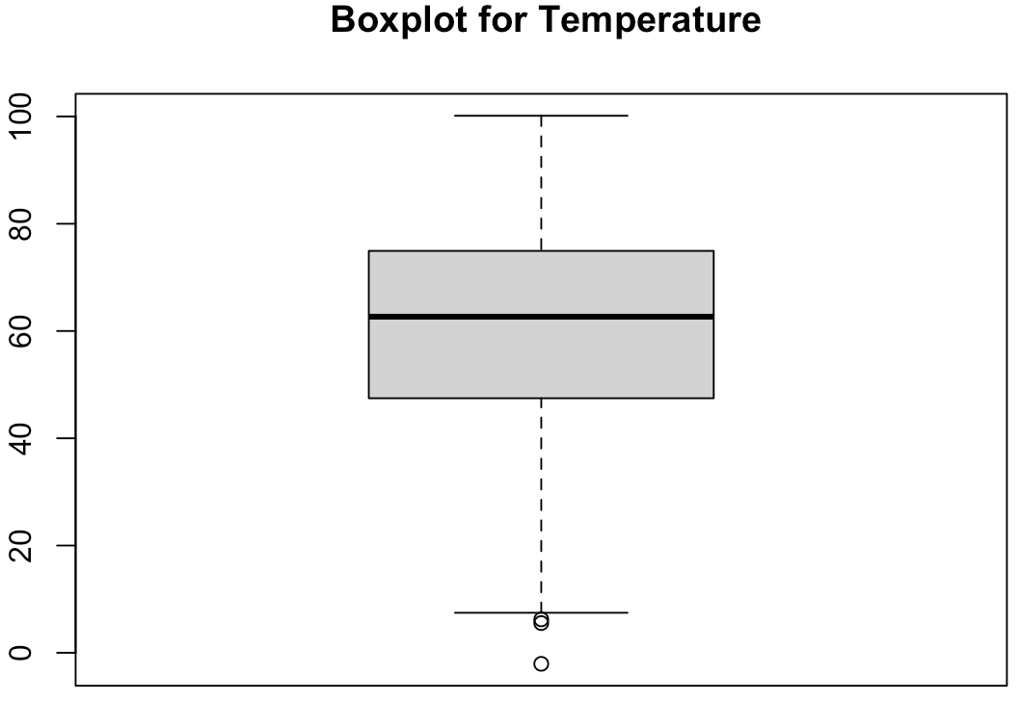

1. CPI

1. Unemployment

1. Fuel price

MODELING USING lm()

model<-lm(Weekly_sales~ Temp+ Fuel_price+CPI+ Unemployment+ Store_number+ Is_Holiday+ Month+ Year, data=walmart)

MODEL USING RANDOM FOREST

rf.fit <- randomForest(Weekly_sales ~ ., data=walmart, ntree=170,keep.forest=FALSE, importance=TRUE)

DIAGNOSTICS

Diagnostic plots

QQ Plot Residual Plot

